**Aim:** To Automate the excel.

**Objectives:** Understand how to Automate excel using the Excel and the Advance Excel Actions.

**Tools Used:** Automation anywhere tools

**Concept:**

**1. Excel advanced: Open:** The Open action in Excel within an Automation Anywhere bot is used to launch an Excel application instance and open a specified workbook.

**2. Excel advanced: Go to Cell:** Moves the active pointer to a designated cell (e.g., A1) within the workbook. Sets the stage for precise data operations such as reading or writing.

**3. Loop**: Repeats a set of actions either a fixed number of times or until a condition is met.  
Automates repetitive tasks within the bot’s workflow efficiently.

**4.Number:toString:** Converts a numeric value into its string representation.  
Enables seamless integration of numbers with text for further processing.

**5. Excel advanced: Set cell Formula:** Inserts a specified Excel formula into a target cell for dynamic calculations. Automates computation by applying standard Excel functions to data.

**6. Excel advanced: Go to next empty cell:** Navigates to the next available empty cell in a column or row. Facilitates appending new data without overwriting existing content.

**7. Number: Increment:** Increases a numeric variable by a defined step, typically by one.  
Supports counter operations and iterative processes within loops.

**Problem Statement:** Automate excel using the Excel and the Advance Excel.

**Solution:**

**Step1:** Open Workbook” action by specifying the full file path

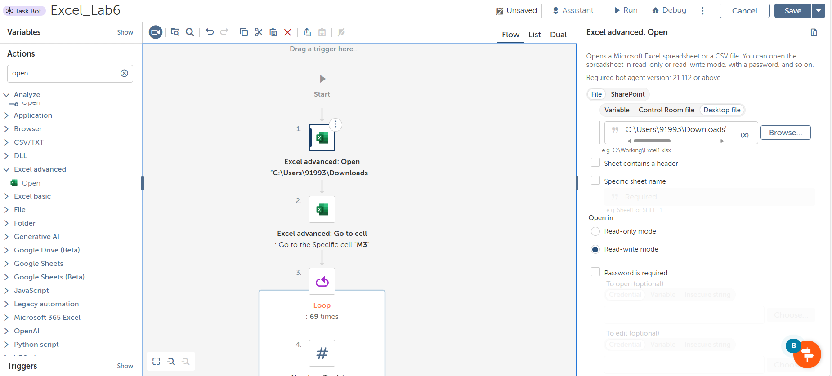

**Step 2**: Select the “Excel Advanced – Go to Cell” action from the action palette. Input the target cell reference M3.

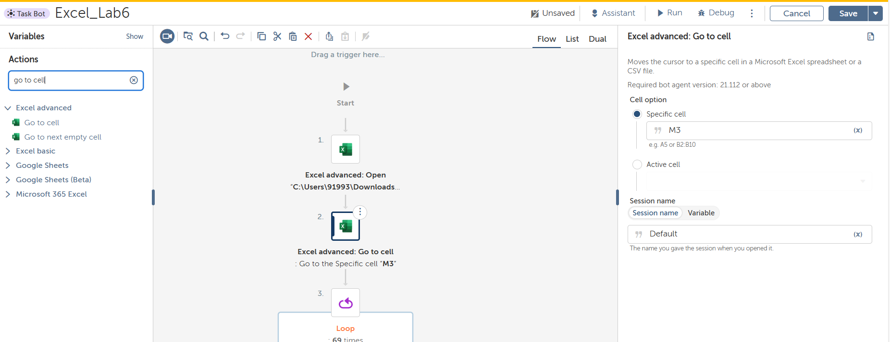

**Step 3:** Now select the loop and run 69 times to calculate the 69 student marks.

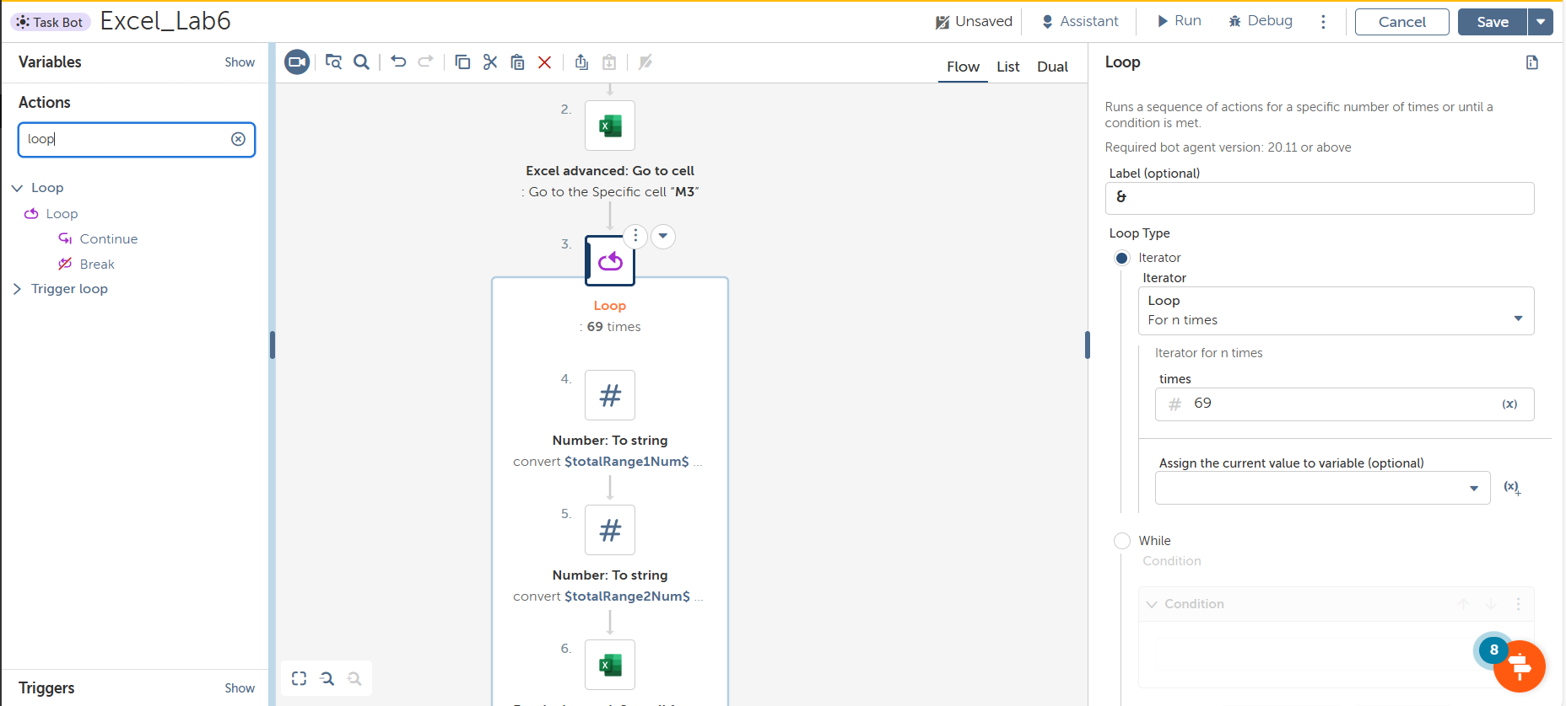

**Step 4:** Create two number variables to define the range for 10 experiments. It will start from row 3 excluding the header part.

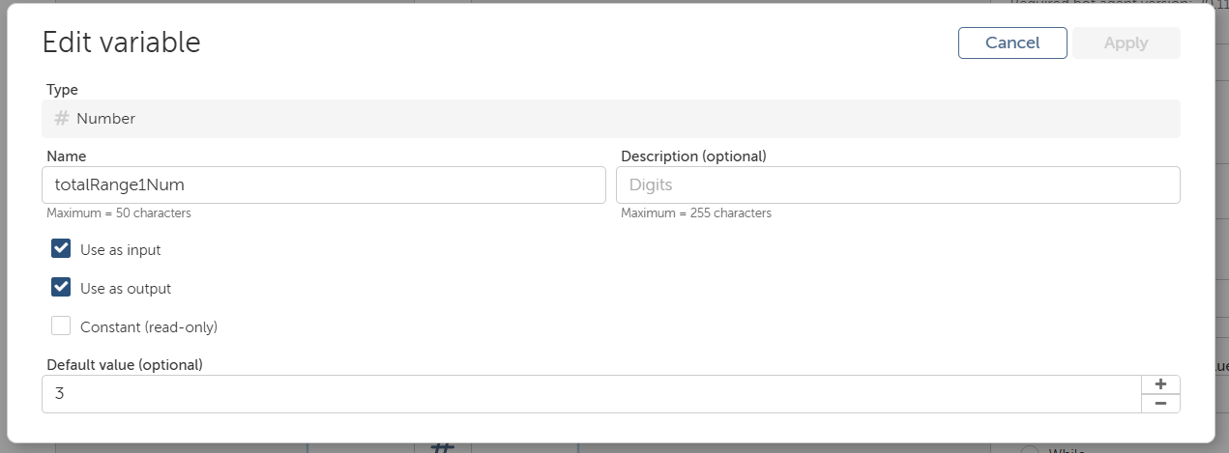

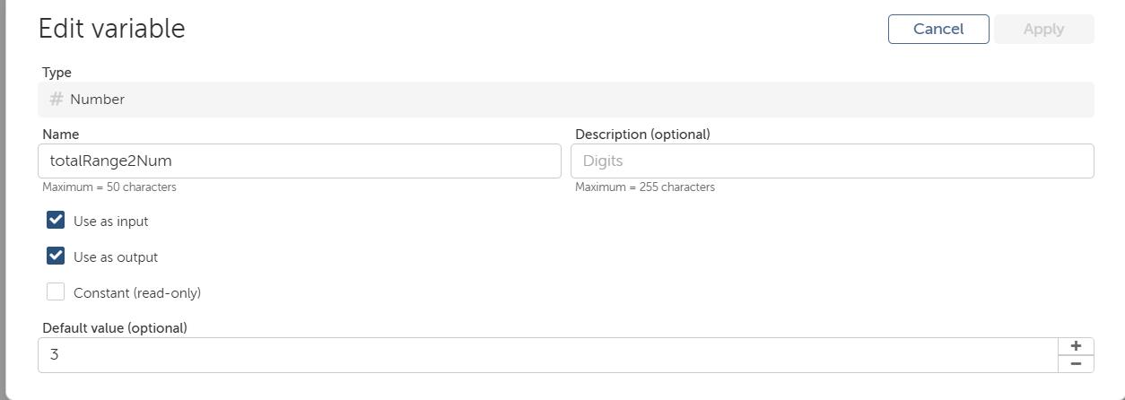

**Step 5:** Convert number to string

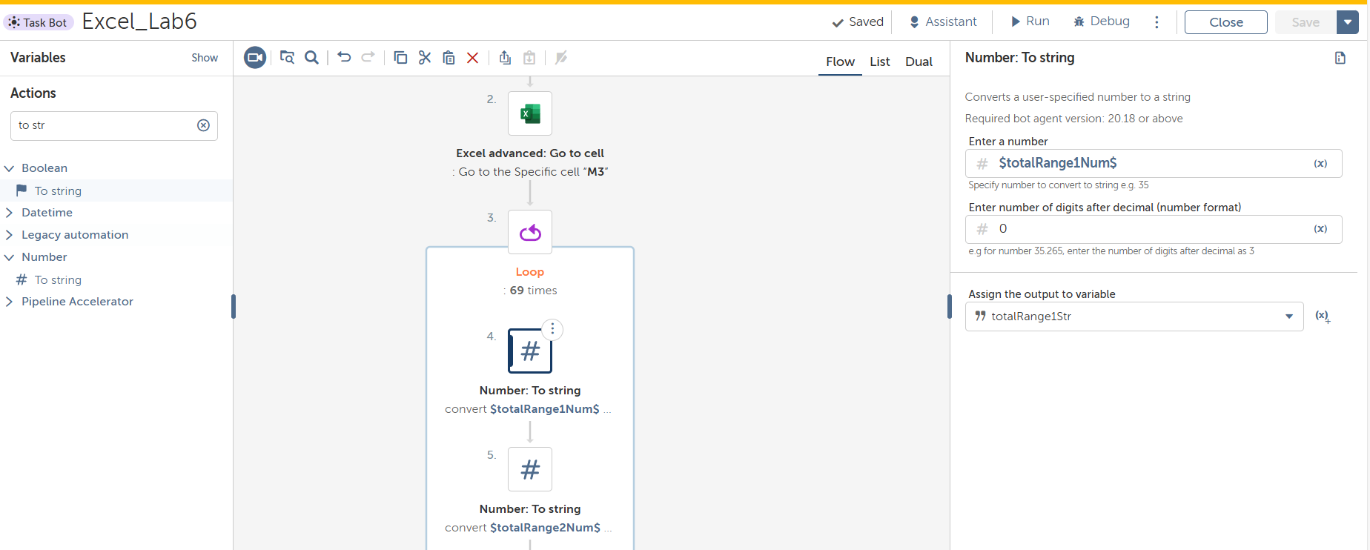

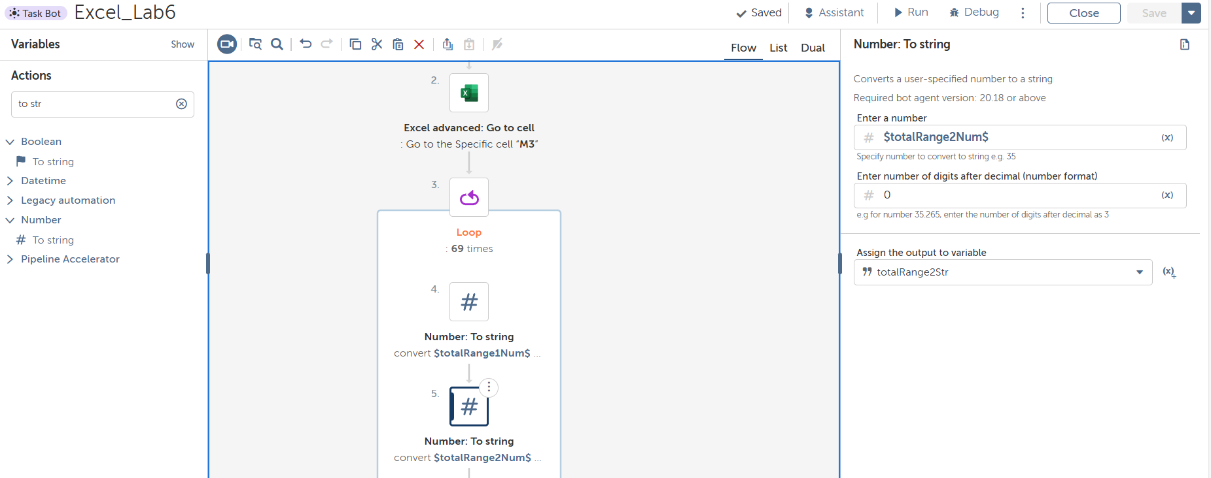

**Step 6:** Choose the Excel Advanced – Set Cell Formula action and choose the active cell and apply the formula to calculate total sum

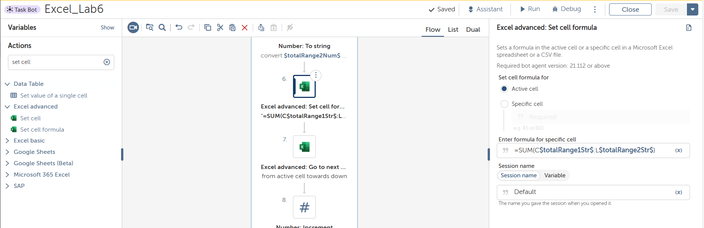

**Step 7:** Select the Excel Advanced – Go to next empty cell action again, to go to next cell.

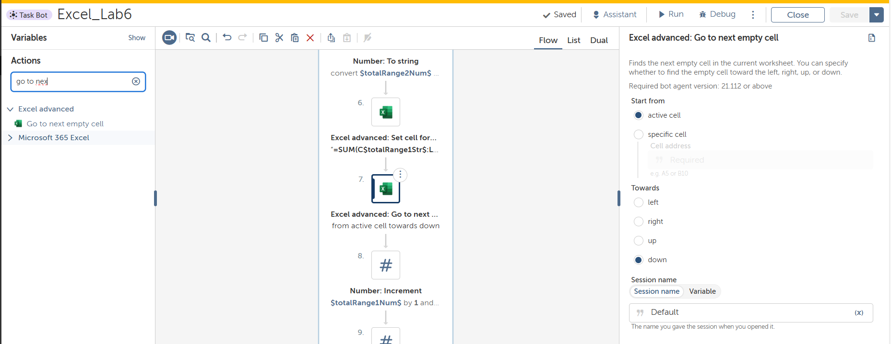

**Step 8:** Now increment both the number by 1 to calculate the total marks of second row.

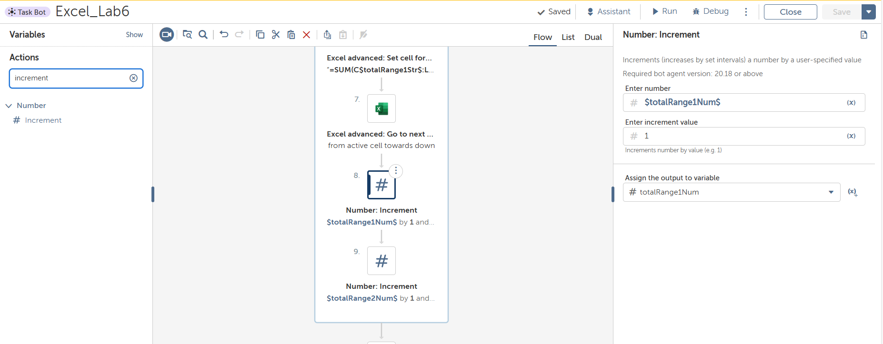

After these it will calculate all the marks of student

Now calculating the result analysis using standard deviation.

**Step 9:** Create the list and add all the column in to the list for e.g. C to M

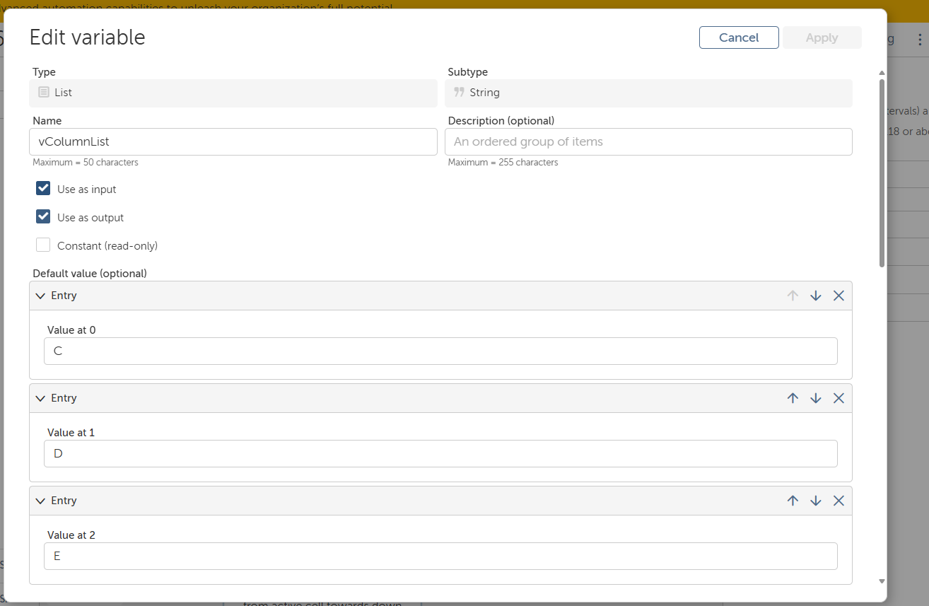

**Step 10:**  Now iterate over the list using loop

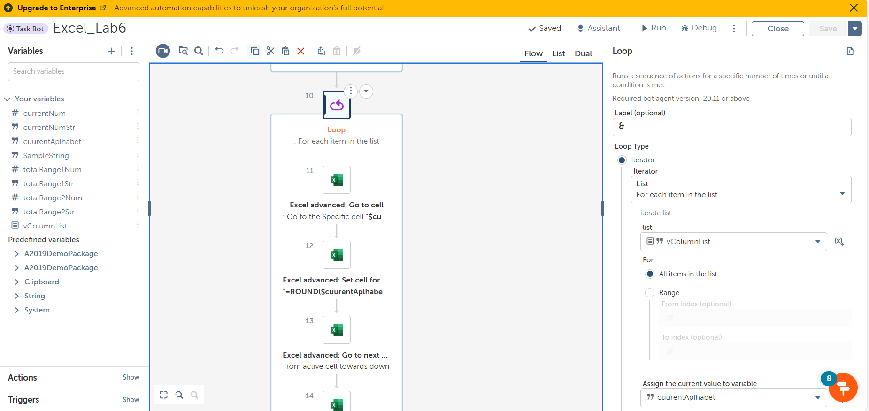

**Step 11:** Store the current list item into variable currentAlphabet.Now select the Excel Advanced -> go to cell and specifies the cell $currentAlphabet$78;

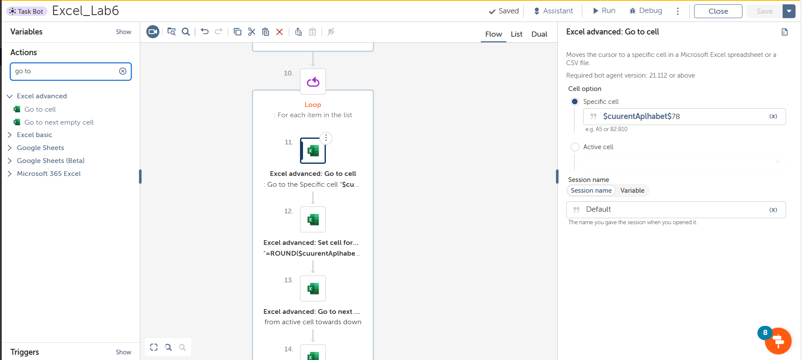

**Step 12:** Now calculate the average using Excel Advanced -> set cell Formula and specifies the formula

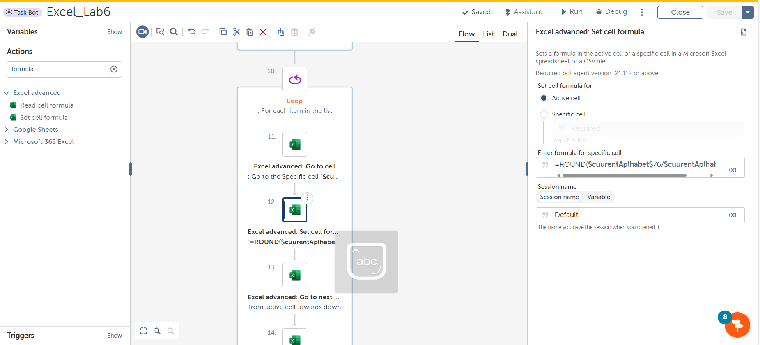

**Step 13:** Now go to next empty cell by using Excel Advanced -> go to next empty cell

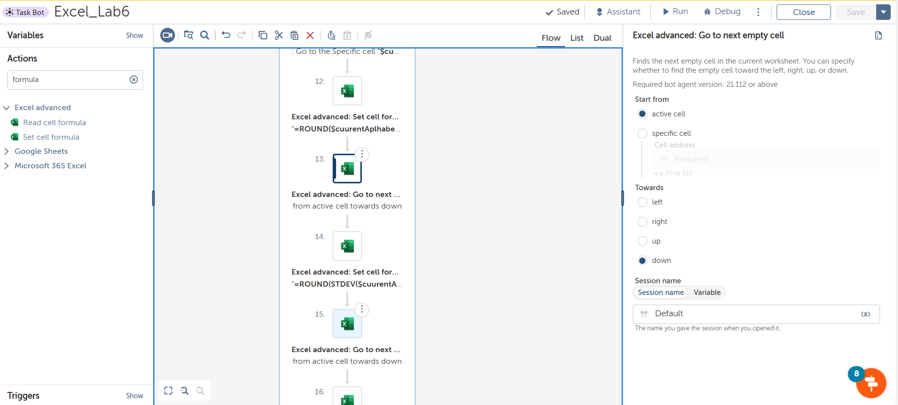

**Step 14:** Select Excel Advanced -> set cell formula to calculate the standard deviation

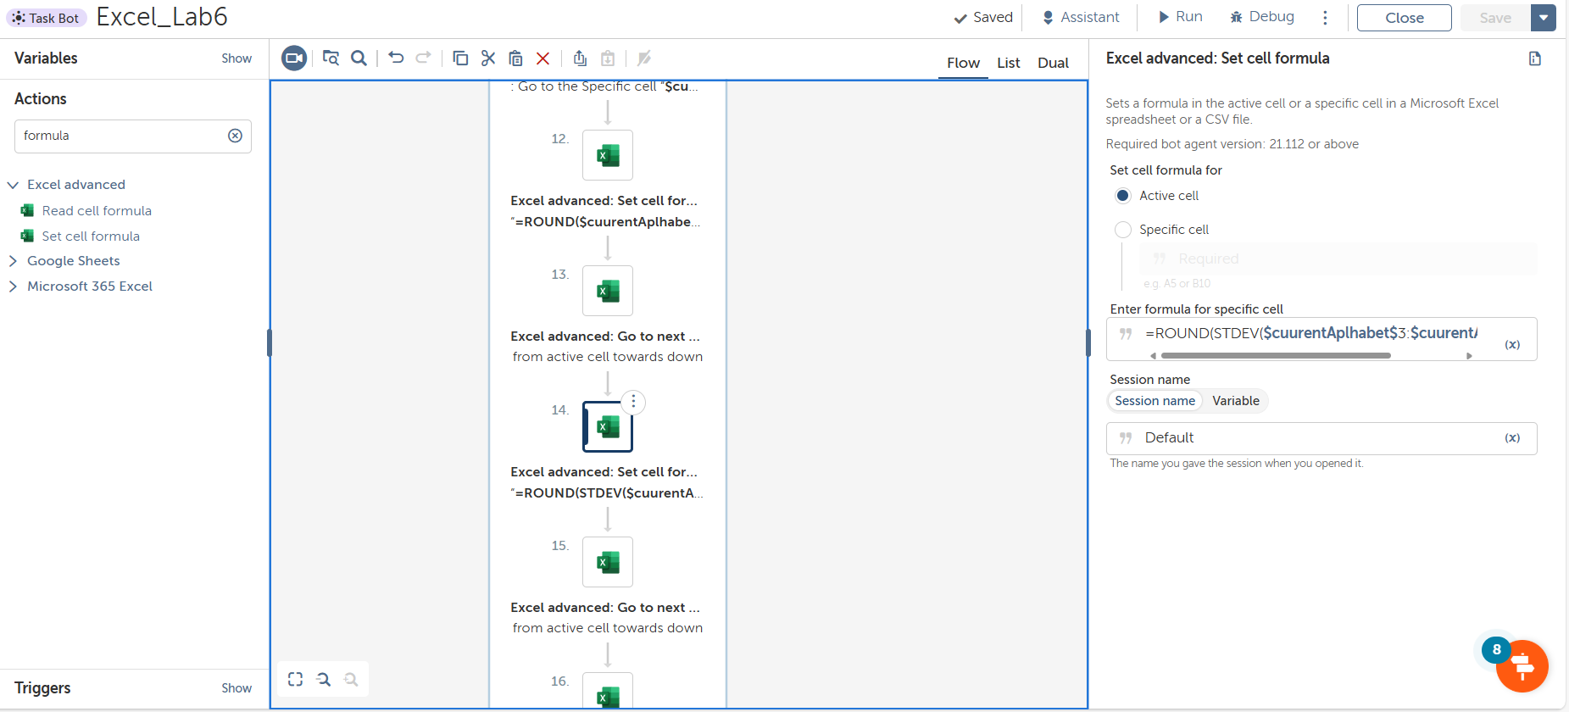

**Step 15:** Now go to next empty cell by using Excel Advanced -> go to next empty cell



**Step 16:** Select Excel Advanced -> set cell formula to calculate the Upper limit

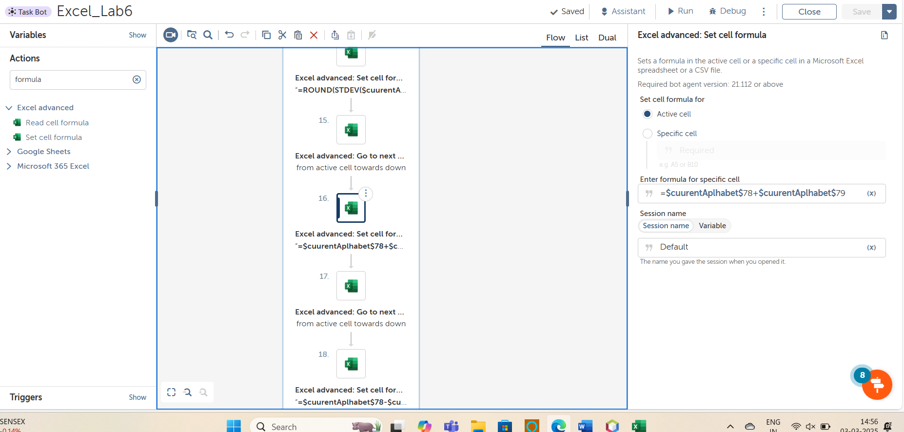

**Step 17:** Now go to next empty cell by using Excel Advanced -> go to next empty cell



**Step 18:** Select Excel Advanced -> set cell formula to calculate the Lower limit

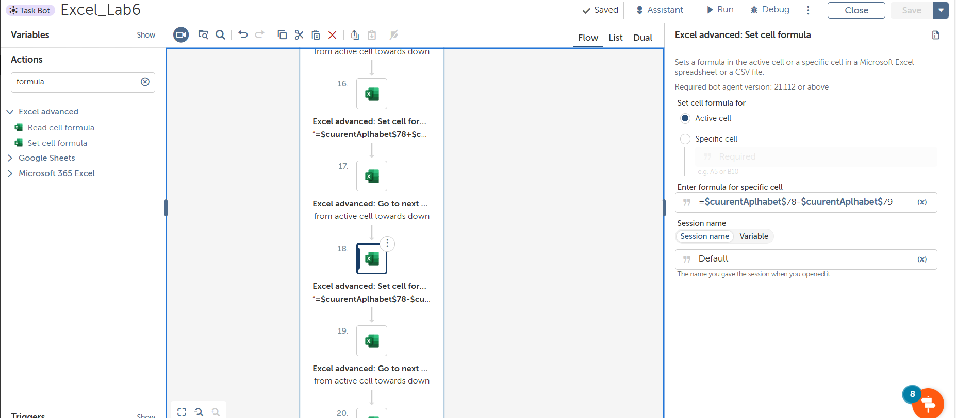

**Step 19:** Now go to next empty cell by using Excel Advanced -> go to next empty cell



**Step 20:** Select Excel Advanced -> set cell formula to calculate the NO.OF STUDENTS IN UPPER TO LOWER RANGE

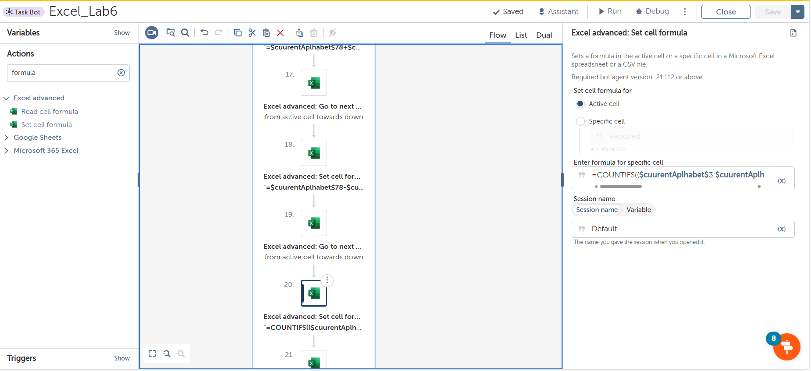

**Step 21:** Now go to next empty cell by using Excel Advanced -> go to next empty cell



**Step 22:** Select Excel Advanced -> set cell formula to calculate the CO ATTAINMENT

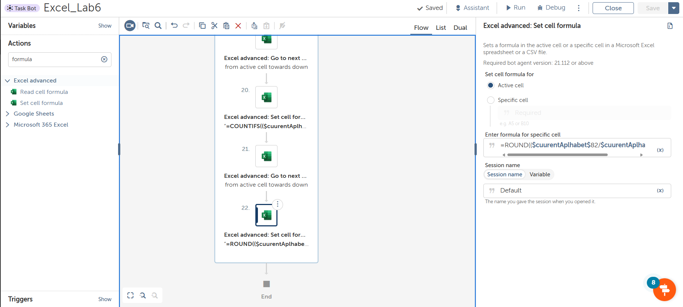

And after this loop will go the second item in the list until the items exhausted

**Output:**

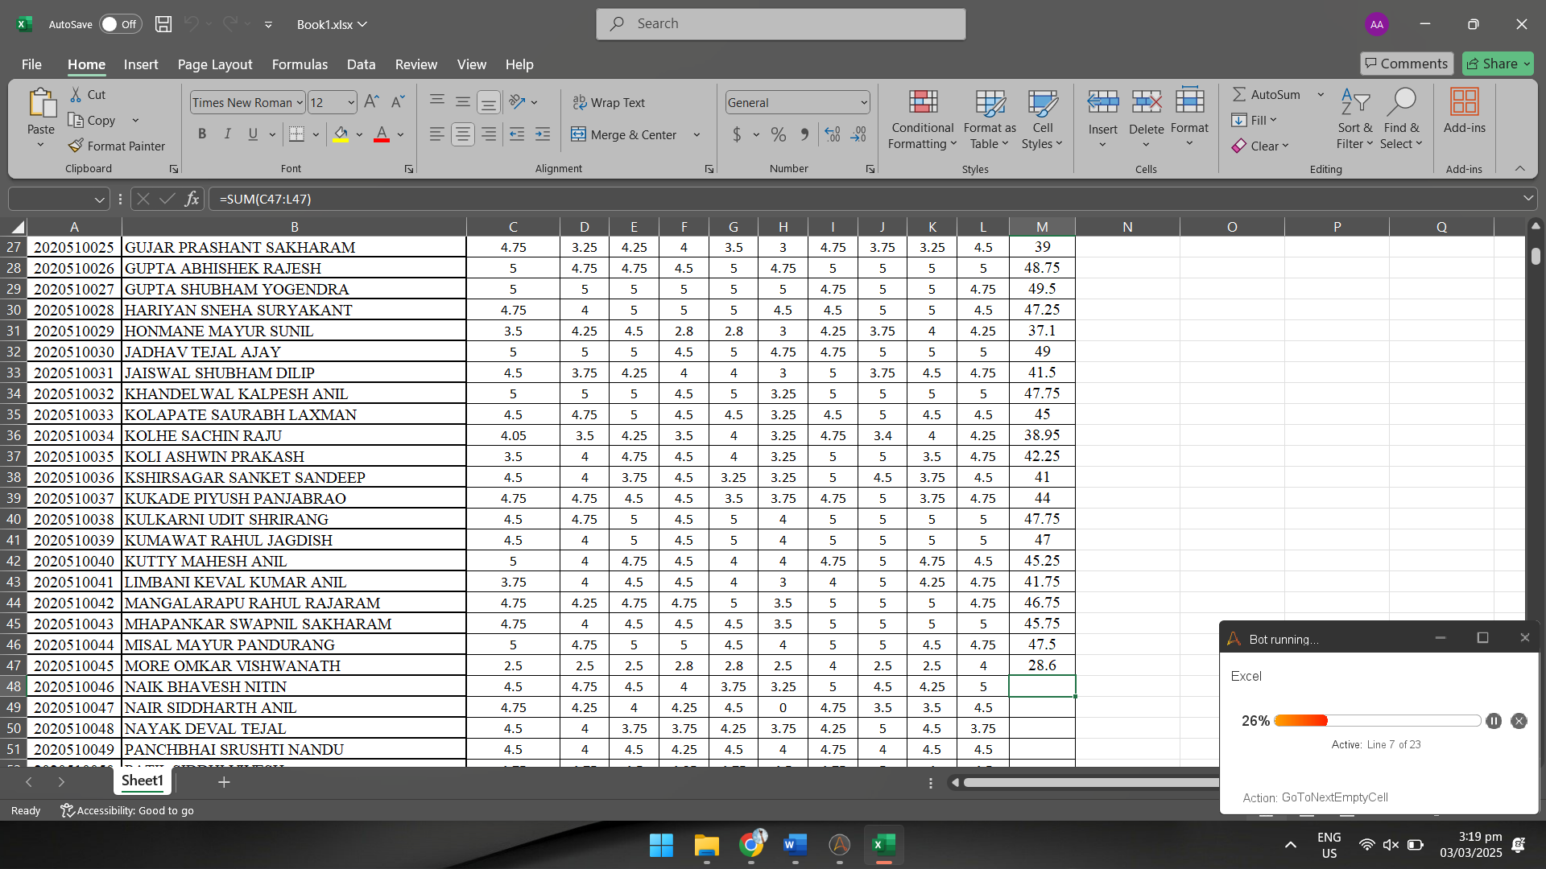

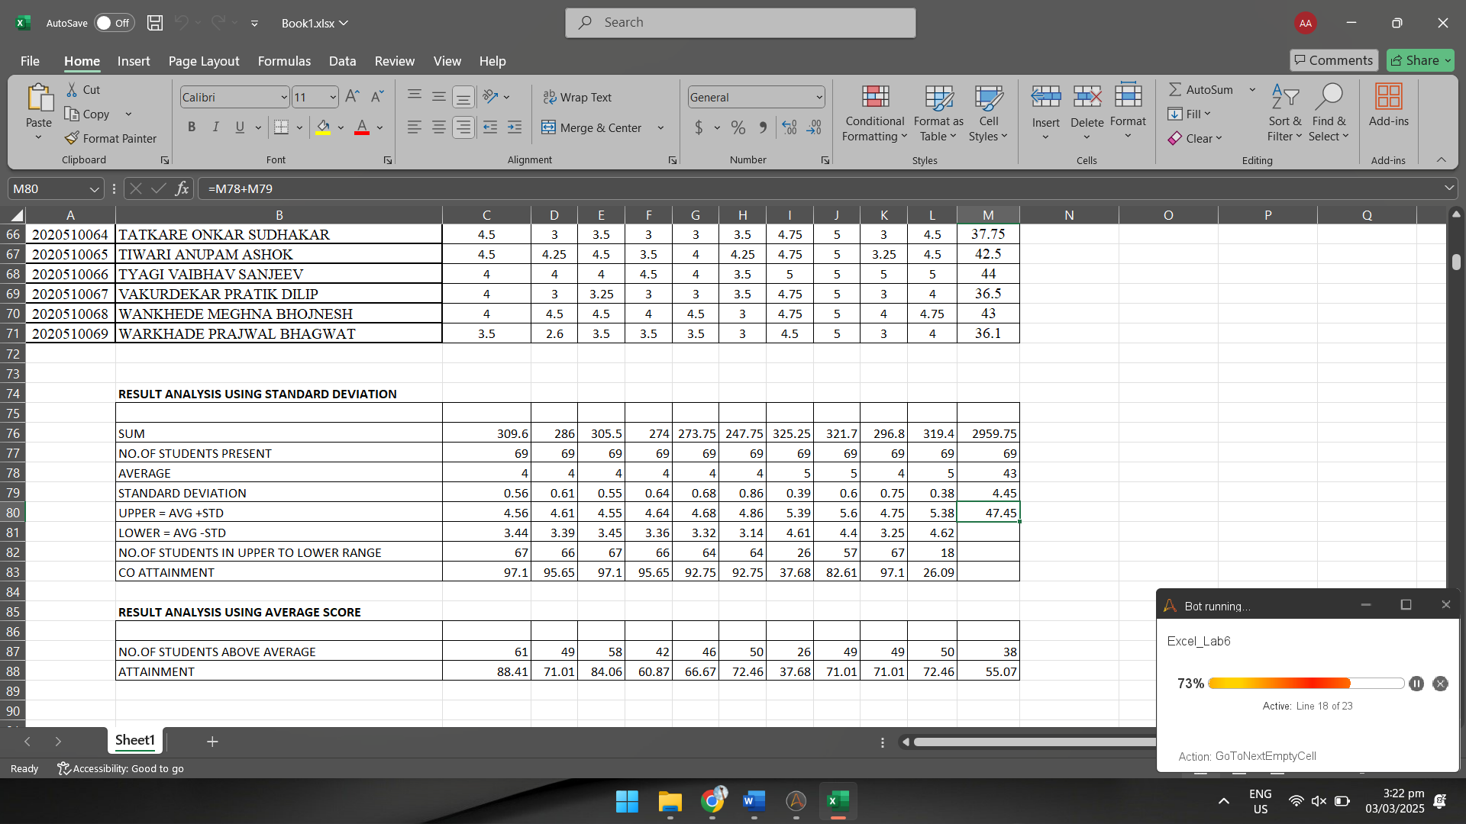

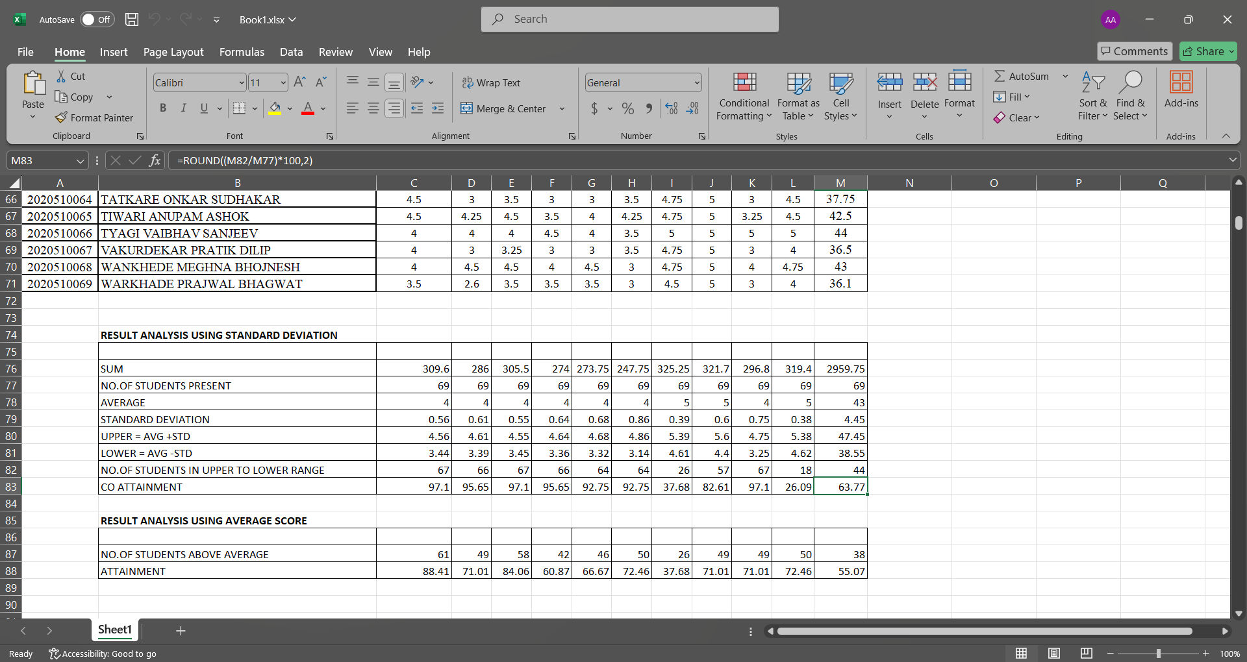

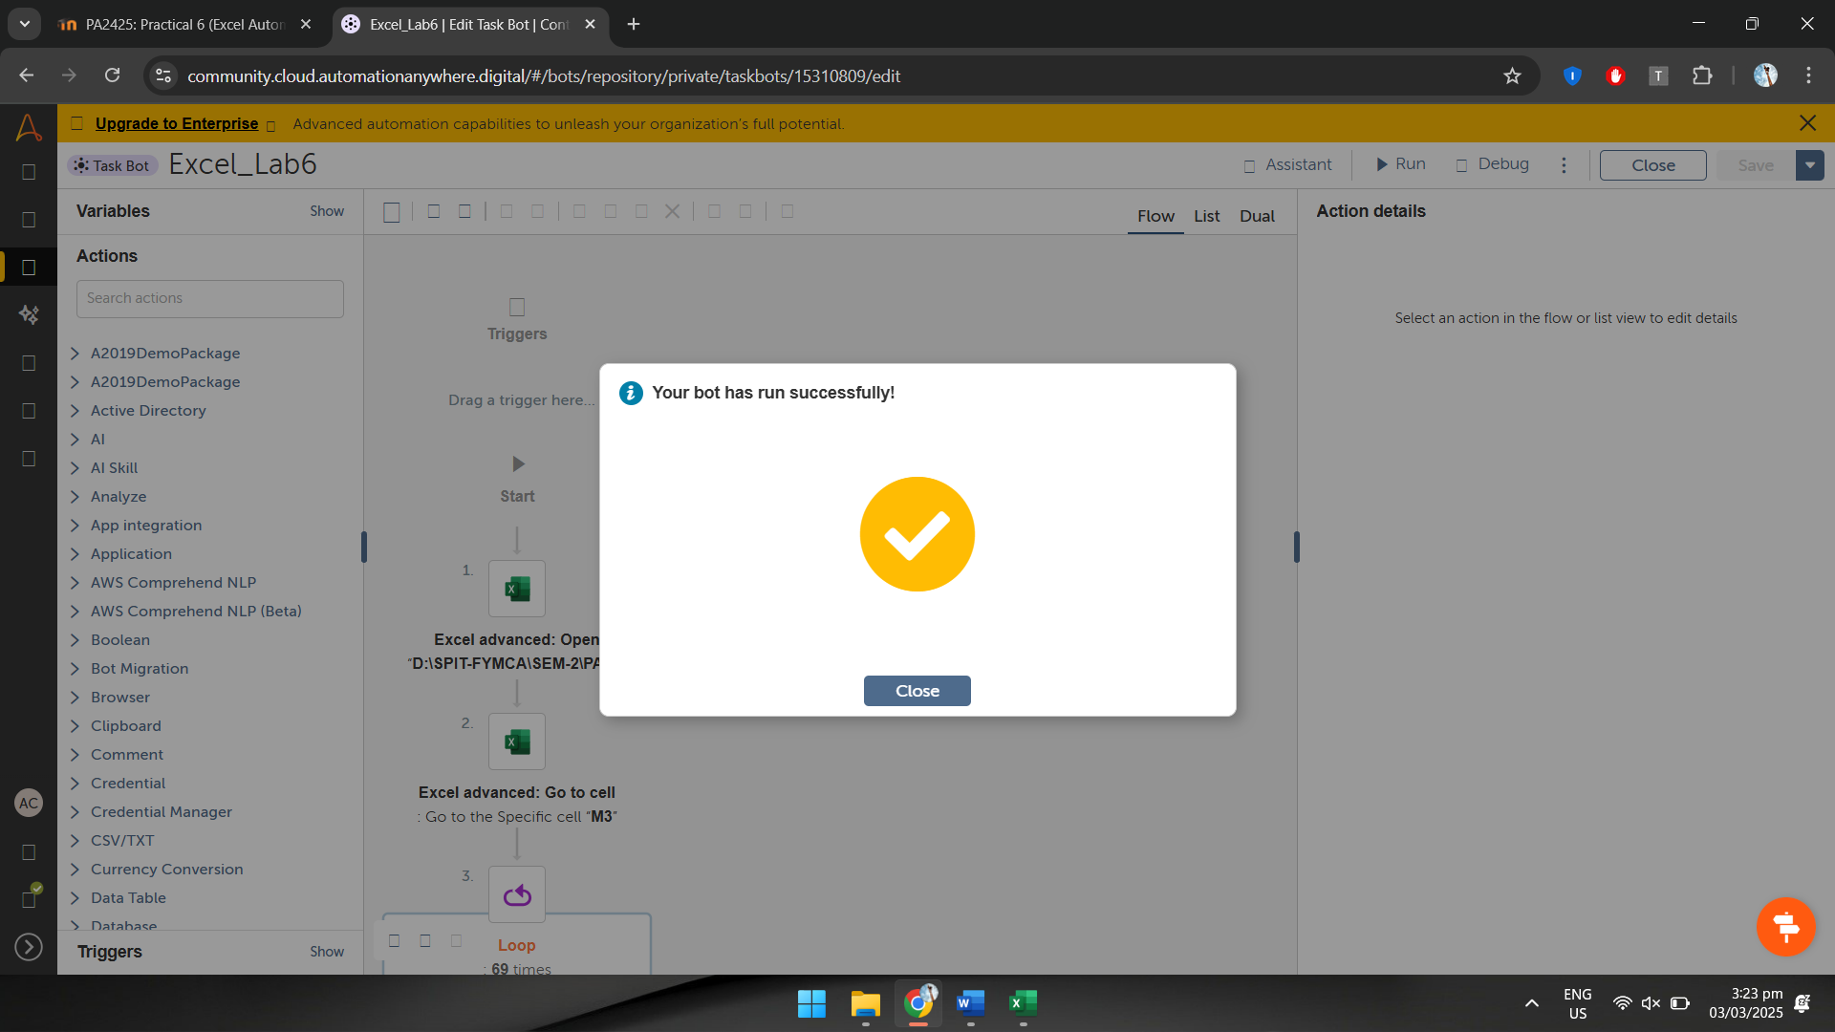

**Observation:**

Automating Excel with Automation Anywhere streamlines data processing, reducing manual effort and errors. Using actions like "Open Workbook," "Go to Cell," and "Set Cell Formula," the bot calculates student marks, performs statistical analysis, and determines attainment levels. Loops and list operations ensure efficient execution across multiple columns. This automation enhances accuracy, speeds up calculations, and improves workflow efficiency for Excel-based tasks.